CAMOSUN COLLEGE
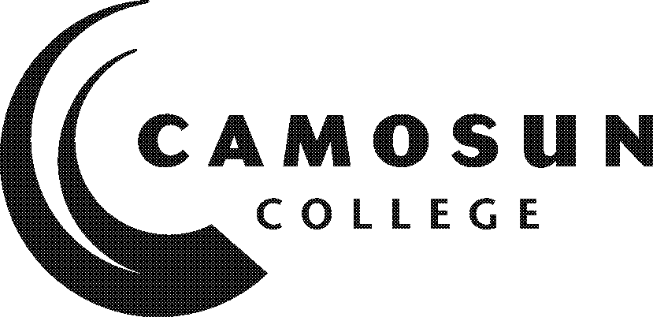
School of Arts & Science
Department of
Applied Chemistry and Biotechnology

CHEM 290

Internship Work Experience 1

Summer 2017

COURSE OUTLINE

The calendar description is available on the web @

 Please note: This outline will not be kept indefinitely. It is recommended students keep this outline for their records, especially to assist in transfer credit to post-secondary institutions.

1. Instructor Information

(a) | Instructor: | Steve McKinnon
(b) | Office Hours: | Please email to arrange a time to meet
(c) | Location: | Fisher 348A
(d) | Phone: | 250-370-3472 | Alternative Phone:
(e) | Email: | mckinnons@camosun.bc.ca
(f) | Website:

2. Intended Learning Outcomes
(If any changes are made to this part, then the Approved Course Description must also be changed and sent through the approval process.)
In addition to the regular Program Learning Outcomes (LO), students who successfully complete work terms will be able to demonstrate learning in the following four areas:

- Occupational and workplace awareness Students will be able to:
- Summarize the duties and responsibilities associated with a given occupation or work role and explain how the role(s) relates to the organization’s strategic objectives.
- Identify at least one scientific and one interpersonal challenge encountered during the work situation, and explain how the program has or has not equipped a student to overcome or alleviate each one.
- Academic/Technical learning Students will be able to:
- Demonstrate knowledge of the integration, application and/or utilization of specific technical skills from the program (e.g., synthetic methodology, analytical techniques, computer skills, quantitative assessment, quality assurance, quality control, applied statistics, technical writing) as they applied to the work experience.
- Articulate relationships between classroom topics in Chemistry, Biochemistry, Immunology, Microbiology or Biotechnology as they relate to actual practices and situations encountered in the laboratory as requirements of the job.
- Employability skills Students will be able to:
- Demonstrate acquisition/improvement of Employability Skills (as defined by the Conference Board of Canada, SCANS, etc.), for example,
- Demonstrate appropriate communication skills utilized in the workplace as identified for different purposes or audiences (e.g., email, oral or written communication).
- Describe how the Applied Chemistry and Biotechnology program assisted you to think critically to solve problems, anticipate outcomes, use and organize information.
- Demonstrate appropriate workplace attitudes and behaviours (responsibility, accountability, initiative, trustworthiness, diligence, friendliness, empathy, etc.).
- Teamwork: Describe any participation in teamwork which occurred formally or informally, including your contribution to what did or did not work and the implications on further skill development.
- Technology: Provide examples of how you used technology or your technical skills to solve problems and achieve results.
- Self-awareness & professional development Students will be able to:
- Describe insights into their own preferences, aptitudes, work habits, style of interaction, learning processes, etc. as revealed through internship work experience.
- Reflect on the work term experience and examine how this will relate to future career plans.

3. Required Materials

(a) Texts n/a

- Other n/a

4. Course Content and Schedule
(Can include: Class hours, Lab hours, Out of Class Requirements and/or Dates for quizzes, exams, lecture, labs, seminars, practicums, etc.)

For self-developed work terms, a proposal which includes a job description and expected learning outcomes needs to be submitted to the Chair of the Applied Chemistry and Biotechnology department and to the Co-op and Internship Coordinator for approval prior to the work term.

Within three weeks of beginning a work term, the student submits to the instructor (CFI):
- A work term learning plan (all work term forms are available on the Camosun College co-op webpage at http://camosun.ca/services/coop/forms.html or on D2L) outlining at least three realistic and measurable goals to be achieved during the work term, including action steps. For self-developed terms, the expected learning outcomes identified in the proposal can be used as part of this more detailed learning plan.
- The goals outlined in the plan must demonstrate a relationship with what the student has learned to date, and explain how successful completion of the plan will tie into the student’s longer term career plans. The student will demonstrate evidence of progressive learning from the previous work term.
- Goals that are not realistic or achievable may be modified as necessary by consultation with the instructor.

At or around the midpoint of the work term, but prior to the scheduled site visit:
- Submission of a midterm reflection to the instructor. This form will be sent to the student at the start of the work term.

At least one week prior to the completion of the work term, the student submits to the instructor:
- a completed Employer Assessment of Learning;
- a completed Student Assessment of Learning;
- an updated resume;
- and a reflective essay outlining the completion of goals identified at the start of the work term and how the term ties into the student’s future career path (specific details on content to be provided to the student). In consultation with the instructor, students may submit a technical report, project or poster instead of an essay.

5. Basis of Student Assessment (Weighting)
(Should be directly linked to learning outcomes.)

To receive a “Completed” (COM) grade for an Internship Work Term, students must meet all of the following criteria:

- Satisfactory completion of all the components outlined above under (4) Course Content and Schedule.
- Submission of the components in a timely manner.
- Receive a “Satisfactory” or better overall evaluation on the Employer Performance Assessment.

To receive a ‘Completed with Distinction’ (DST) grade for the work term, students must meet all of the following criteria:

- Exemplary completion of all the components outlined above under (4) Course Content and Schedule.
- Submission of the components in a timely manner.
- Receive a “Very Good” or better overall evaluation on the Employer Performance Assessment.

6. Grading System
(If any changes are made to this part, then the Approved Course description must also be changed and sent through the approval process.)
(Mark with “X” in box below to show appropriate approved grading system – see last page of this template.)
 | Standard Grading System (GPA)
X | Competency Based Grading System

7. Recommended Materials or Services to Assist Students to Succeed Throughout the Course

LEARNING SUPPORT AND SERVICES FOR STUDENTS

There are a variety of services available for students to assist them throughout their learning. This information is available in the College Calendar, Student Services or the College web site at http://www.camosun.bc.ca

STUDENT CONDUCT POLICY

There is a Student Conduct Policy. It is the student’s responsibility to become familiar with the content of this policy. The policy is available in each School Administration Office, Registration, and on the College web site in the Policy Section.
http://www.camosun.bc.ca/policies/policies.html

- Grading Systems http://www.camosun.bc.ca/policies/policies.php
The following two grading systems are used at Camosun College:
1. Standard Grading System (GPA)
Percentage | Grade | Description | Grade Point Equivalency
90-100 | A+ |  | 9
85-89 | A |  | 8
80-84 | A- |  | 7
77-79 | B+ |  | 6
73-76 | B |  | 5
70-72 | B- |  | 4
65-69 | C+ |  | 3
60-64 | C |  | 2
50-59 | D |  | 1
0-49 | F | Minimum level has not been achieved. | 0
2. Competency Based Grading System (Non GPA)
This grading system is based on satisfactory acquisition of defined skills or successful completion of the course learning outcomes
Grade | Description
COM | The student has met the goals, criteria, or competencies established for this course, practicum or field placement.
DST | The student has met and exceeded, above and beyond expectation, the goals, criteria, or competencies established for this course, practicum or field placement.
NC | The student has not met the goals, criteria or competencies established for this course, practicum or field placement.
- Temporary Grades
Temporary grades are assigned for specific circumstances and will convert to a final grade according to the grading scheme being used in the course. See Grading Policy at http://www.camosun.bc.ca/policies/E-1.5.pdf for information on conversion to final grades, and for additional information on student record and transcript notations.
Temporary Grade | Description
I | Incomplete: A temporary grade assigned when the requirements of a course have not yet been completed due to hardship or extenuating circumstances, such as illness or death in the family.
IP | In progress: A temporary grade assigned for courses that are designed to have an anticipated enrollment that extends beyond one term. No more than two IP grades will be assigned for the same course.
CW | Compulsory Withdrawal: A temporary grade assigned by a Dean when an instructor, after documenting the prescriptive strategies applied and consulting with peers, deems that a student is unsafe to self or others and must be removed from the lab, practicum, worksite, or field placement.

