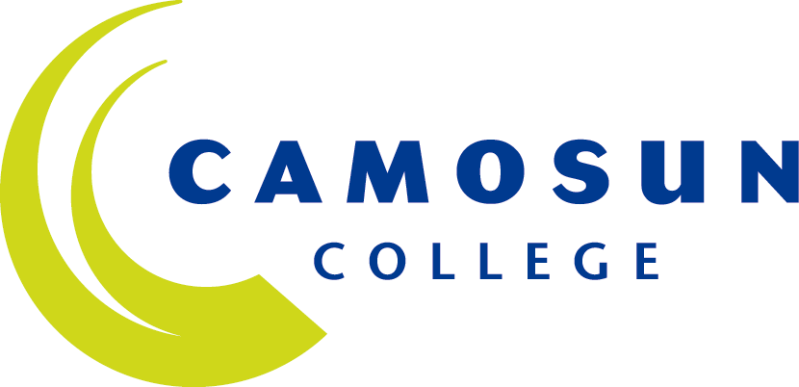 | School of Arts & Science
 | CHEMISTRY AND GEOSCIENCE DEPARTMENT
 | CHEM 100-001
 | Introductory Chemistry
 | 2017S

COURSE OUTLINE

The course description is online @ http://camosun.ca/learn/calendar/current/web/chem.html

 Please note: the College electronically stores this outline for five (5) years only.
It is strongly recommended you keep a copy of this outline with your academic records.
You will need this outline for any future application/s for transfer credit/s to other colleges/universities.

1. Instructor Information

Instructor: | Diana Li
Office Hours: | Monday to Thursday 14:30-15:20, or by appointment.
Location: | F344C
Phone: | 250-370-3444
Email: | lid@camosun.bc.ca
Website: | http://camosun.ca/learn/programs/chem.html

**To avoid class interruptions & cancellations, please refrain from wearing fragrance or other strongly scented products to class!**

2. Intended Learning Outcomes
(No changes are to be made to these Intended Learning Outcomes as approved by the Education Council of Camosun College.)

Upon completion of this course, the student will be able to:

- Use dimensional analysis, metric and SI units in performing chemical calculations.
- Utilize the specialized vocabulary and nomenclature of chemistry and name chemical compounds, and identify and construct chemical formulas.
- Summarize the characteristics of electrons, protons and neutrons, and identify their roles as components of atoms, ions and isotopes, including radioisotopes.
- Describe atomic structure, the differences between elements, and the role of the periodic table in organizing elements within a coherent theoretical and empirical system.
- Describe and account for the periodic table trends concerning atomic number, atomic radius, ionization energy and electronegativity.
- Compare the formation and characteristics of ionic and molecular compounds.
- Perform mathematical calculations involving chemical formulas, molecular weights, moles, Avogadro’s number and Molarity.
- Balance chemical equations, including use of the mole concept, and solve stoichiometry problems.
- Account for the general characteristics of the gas, liquid, and solid states.
- Conduct experiments in basic chemistry, utilizing common chemistry laboratory equipment with an enhanced knowledge and practice in basic lab skills.

3. Required Materials

Texts | Required:  ♦ Chem 100 Course Notes / Lab Manual / Problem Sets, Department of Chemistry & Geoscience, Camosun College. 2013.
Other | Eye protection is mandatory in the lab & lab coat is highly recommended.

4. Course Content and Schedule

Lecture Plan:
Unit | Topic (approx. # of lecture hours) | Unit | Topic (approx. # of lecture hours)
1 | Measurements & Calculations (4) | 7 | Chemical Bonding (5)
2 | Introductory Terminology (4) | 8 | Gases (5)
3 | Chemical Formulas & Names (5) | 9 | Liquids & Solutions (3)
4 | Calculations Based Upon Formulas (4) | 10 | Organic Chemistry (3)
5 | Stoichiometry (4) | 11 | Radioactivity (2)
6 | Periodic Table & Electron Distributions (3)

5. Basis of Student Assessment (Weighting)

(This section should be directly linked to the Intended Learning Outcomes.)
Labs (up to 9 experiments) | 20%
Test I (Units 1-3) | 20% (Week III Wednesday, May 17 Lab Period)*
Test II (Units 4-6) | 20% (Week V Wednesday, May 31 Lab Period)*
Final Exam (comprehensive) | 40% (TBA ~Week IV, 3 hours in June)

* Test dates to be confirmed during the first week of classes in May.

Notes:
- Student must pass the lab portion of the course to obtain credit for Chem 100. Your lab faculty will go over the lab component of Chem 100 and lab evaluation with you…
- Student is encouraged to attempt both tests. Test score that is not as high as that of the June final exam will be dropped automatically and its weight redistributed to the final exam. However, anyone who is caught cheating will receive zero for that test which will not be redistributed. For anyone who misses both tests, your final exam will then be 80% of the course grade!
- Student must write each test in the lab period as scheduled for his/her section. No one is allowed to write late and there will be no exceptions. Early exam is a privilege and not a right; thus, at full discretion of the instructor.

6. Grading System

(No changes are to be made to this section unless the Approved Course Description has been forwarded through the Education Council of Camosun College for approval.)

Standard Grading System (GPA)

Percentage | Grade | Description | Grade Point  Equivalency
90-100 | A+ |  | 9
85-89 | A |  | 8
80-84 | A- |  | 7
77-79 | B+ |  | 6
73-76 | B |  | 5
70-72 | B- |  | 4
65-69 | C+ |  | 3
60-64 | C |  | 2
50-59 | D | Minimum level of achievement for which credit is granted; a course with a "D" grade cannot be used as a prerequisite. | 1
0-49 | F | Minimum level has not been achieved. | 0

Temporary Grades

Temporary grades are assigned for specific circumstances and will convert to a final grade according to the grading scheme being used in the course. See Grading Policy E-1.5 at camosun.ca for information on conversion to final grades, and for additional information on student record and transcript notations.

Temporary  Grade | Description
I | Incomplete: A temporary grade assigned when the requirements of a course have not yet been completed due to hardship or extenuating circumstances, such as illness or death in the family.
IP | In progress: A temporary grade assigned for courses that, due to design may require a further enrollment in the same course. No more than two IP grades will be assigned for the same course. (For these courses a final grade will be assigned to either the 3rd course attempt or at the point of course completion.)
CW | Compulsory Withdrawal: A temporary grade assigned by a Dean when an instructor, after documenting the prescriptive strategies applied and consulting with peers, deems that a student is unsafe to self or others and must be removed from the lab, practicum, worksite, or field placement.

7. Important Dates

Week
III Test I in F356: May 17 (Wed) 13:30-15:20
IV May 22 (Mon): Victoria Day
V May 29 (Mon): Last Day to Withdraw or Change to Audit…
Test II in F356: May 31 (Wed) 13:30-15:20

June 19: First Day of Exams for Summer 2017

8. Recommended Materials or Services to Assist Students to Succeed Throughout the Course

LEARNING SUPPORT AND SERVICES FOR STUDENTS

There are a variety of services available for students to assist them throughout their learning.
This information is available in the College calendar, at Student Services, or the College web site at
camosun.ca.

STUDENT CONDUCT POLICY

There is a Student Conduct Policy which includes plagiarism.
It is the student’s responsibility to become familiar with the content of this policy.
The policy is available in each School Administration Office, at Student Services,
and the College web site in the Policy Section.

Students may not use recording devices in the classroom without the prior permission of the instructor. However, the instructor’s permission is not required when the use of a recording device is sanctioned by the College’s Resource Centre for Students with Disabilities in order to accommodate a student’s disability and when the instructor has been provided with an instructor notification letter which specifies the use of a recording device. Recordings made in the classroom are for the student’s personal use only, and distribution of recorded material is prohibited.

